**-------------------------------IMPORTANT---------------------------**

When at home, connected to your home network, visit – <http://intranet.wmc.ac.uk/ip.php> - and email the resulting IP address to [it.team@wmc.ac.uk](mailto:it.team@wmc.ac.uk).

We can then update the firewall to grant you access to remote access.

**----------------------------------------------------------------------------**

Install Microsoft RD Client from your App store.

Open RD Client

Click on **+** symbol (top right of screen)

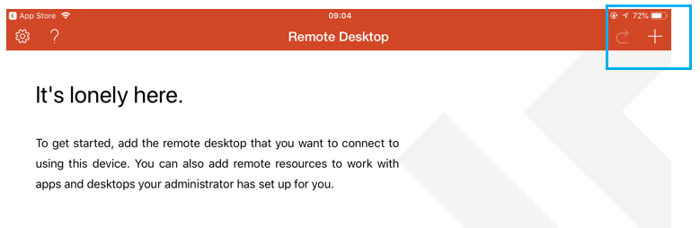

Click **Desktop**

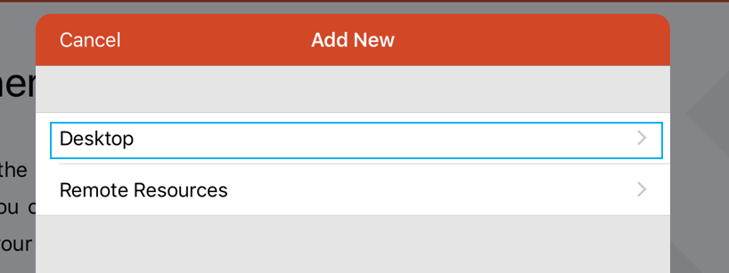

Click on Host name and enter **remote.wmc.ac.uk** and click **Done**

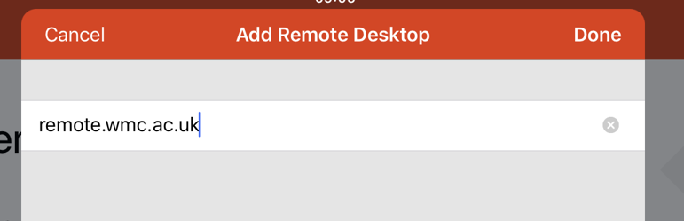

Click on **User Account** and then **Add User Account**

Enter your college username (WMC\username) and your password and click **Save**

Click **Save**

Click on the remote.wmc.ac.uk shortcut

Turn on the “Don’t ask me again for connection to this computer” and press **Accept**

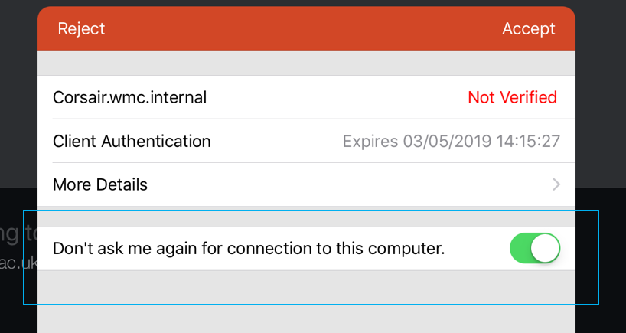

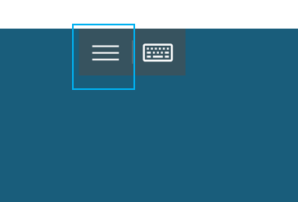At the following screen press the 3 parallel bars at the top of the screen and press the **Touch** button on the right.



You now login as you would on a college computer.

